Assignment 25.3

Problem Statement:

Get a list of employees who receive a salary less than 100, compared to their immediate employee with higher salary in the same unit Hive commands.

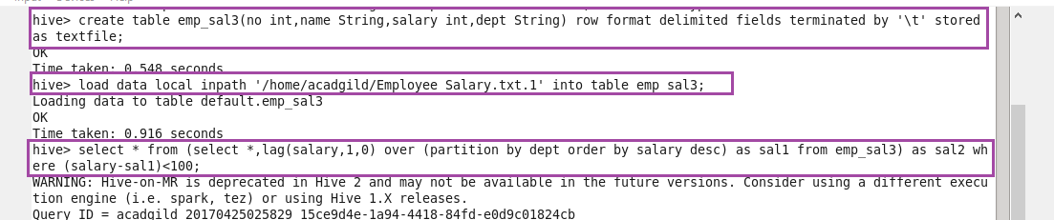

First, creating a table emp_sal3 then loading the given data into created table.

Now, using lag function it is finding that subtraction of employee salary and the salary of previous employee is less than 100 or not.If it is less than 100 it will display the desire output.

**Output :**

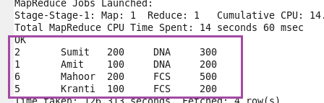

Problem Statement:

List of all employees who draw higher salary than the average salary of that department.

Here, using avg function finding the employees who draws higher salary than the average salary with output.

